TEAM -1-PROJECT
PROJECT _3
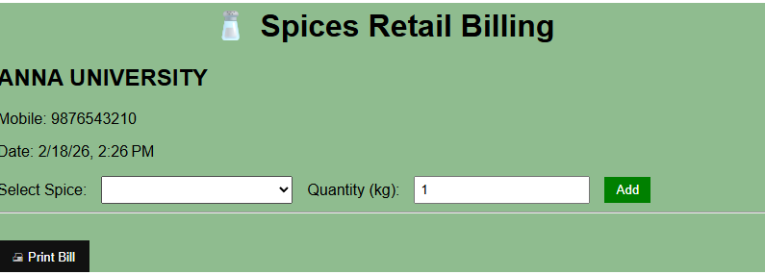

- Create an Angular component that stores the spice list, selected spice, quantity, cart items, and total amount in the TypeScript file.
- Use two-way binding ([(ngModel)]) to bind the dropdown and quantity input to component variables.
- On Add button click, calculate price (price × quantity) and push the item into a cart array, updating the total.
- Display bill details using *ngFor and use window.print() to print the bill.

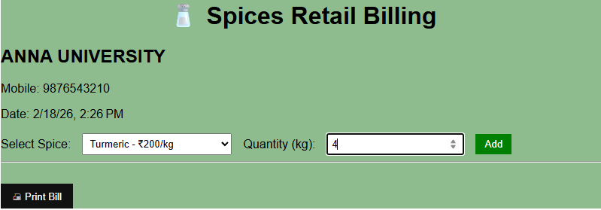

• The Angular component stores spice data, selected item, quantity, and total amount in the TypeScript file.
• The dropdown and quantity input use two-way binding (ngModel), and the Add button calculates price (rate × kg) and updates the cart.
• The bill details are displayed using *ngFor, and the Print Bill button calls window.print() to generate the invoice.

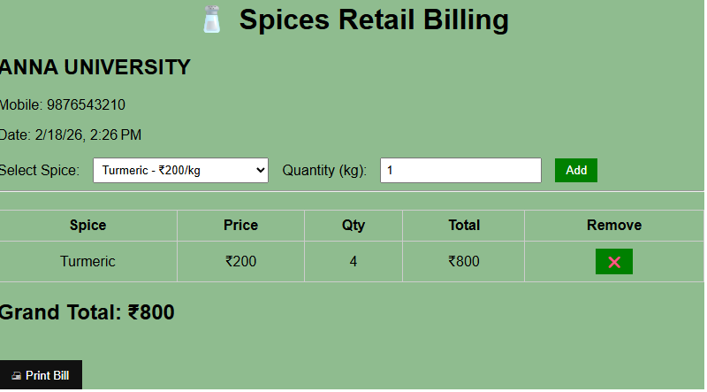

• The Angular component stores spices, selected item, quantity, cart list, and grand total in the TypeScript file.
• The dropdown and quantity input use two-way binding ([(ngModel)]), and the Add button pushes items into the cart array.
• The table displays added items using *ngFor, and the Remove (X) button deletes an item and updates the total.
• The Grand Total is calculated dynamically, and the Print Bill button uses window.print() to print the invoice.

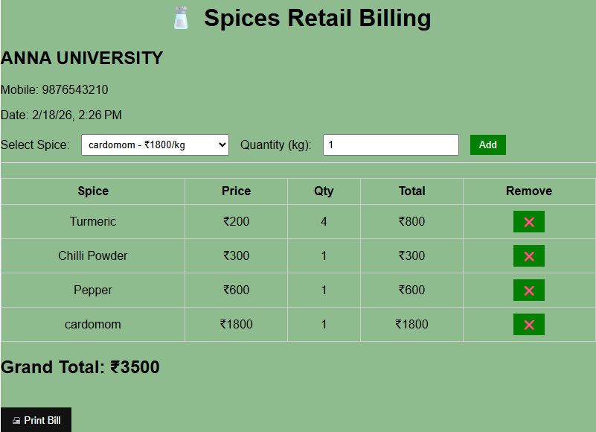

This image shows an Angular-based Spices Retail Billing system with multiple items added to the cart.
The user selects a spice (like cardamom ₹1800/kg), enters quantity, and clicks Add, which stores items in a cart array.
The table displays each item using *ngFor, showing Spice, Price, Quantity, Total, and a Remove (X) button to delete items dynamically.
The Grand Total (₹3500) is automatically calculated by summing all item totals, and the Print Bill button prints the invoice.

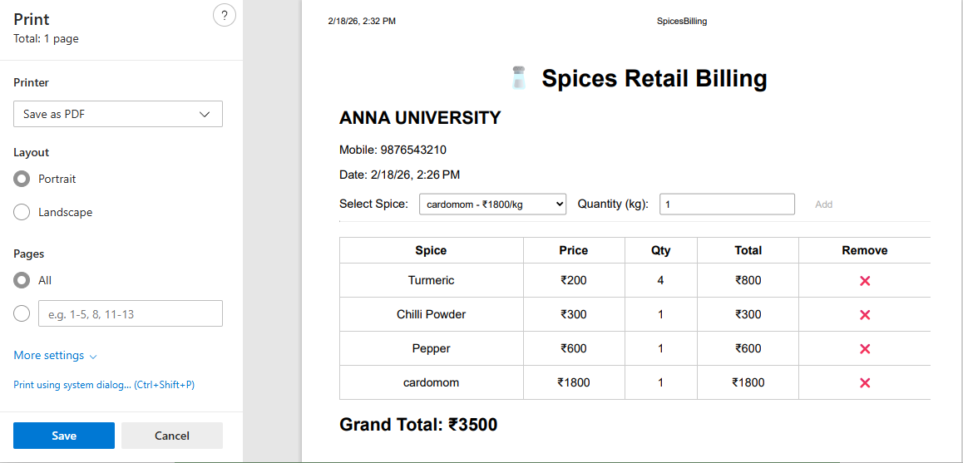

This image shows the Angular billing application in print preview mode, triggered using window.print() from the component.
The bill data (shop details, items, and grand total ₹3500) is dynamically rendered using Angular bindings like {{ }} and *ngFor.
Before printing, Angular calculates totals from the cart array and displays them in a formatted table.
The browser’s print dialog (Save as PDF option) allows the user to download or print the generated invoice.

